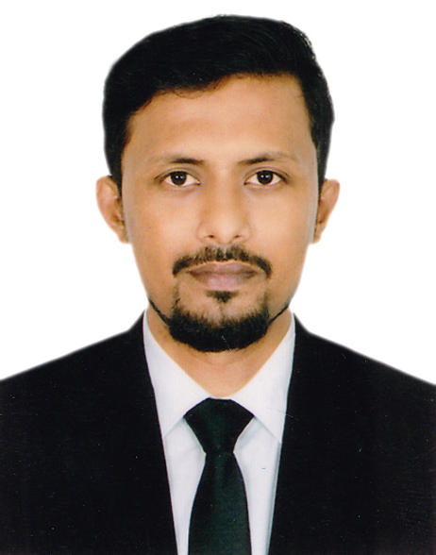
Sk. A.H.M. Arefin

324/a zafrabad, shonkar, Dhaka
Mob : +8801718-723873
Email: arefinshovonbd@gmail.com

Career Objective

Seeking career in a reputed company where there are sample scopes to prepare as a professional. I also expect to work with a company where I will be able to expose myself to every opportunity through a quality and growth oriented job.

Intend to work in a challenging and competitive field of banking & multinational company also showing strong sense of responsibility, dignity of works and devotion for building a bright career and developing the organization.
Provide the knowledge, Skill, Expertise and effort in various qualitative applications.

Experience:

1. SCHEMA Limited
Rohomenia International Complex (7th Floor)
28/1/C Toyenbee Circular Road, Dhaka-1000.
Designation: Specialist, Receivable Resolution
Duration: September 01, 2019 to till now.
Responsibilities: Personal loan sales.

2. The City Bank Ltd.
Al-Razi Complex (16th Floor)
166-167, Shaheed Syed Nazrul Islam Sarani, Purana Paltan, Dhaka-1000.
Designation: Trainee Product Marketing Officer
Duration: May 13, 2019 to August 31, 2019
Responsibilities: Personal loan sales.

3. Peoples Radio 91.6 fm
Gulshan 2 , Dhaka, 41 DIT II Cir,
Dhaka 1212, Bangladesh
Designation: Jr. Accounts executive
Duration: May 10, 2015 to July 2016
Responsibilities: Follow up financial activities

4. Freelance event management
Dhanmondi 27, Dhaka
Designation: Chip executive
Duration: Jan 1, 2014 to Present
Responsibilities: communicates on behalf of overall event management activities.

Communication Skills :

- Fluent in English & Bengali-Both verbal & written.
- Proficient in Writing and editing reports.
- Efficient in multimedia presentation.

Computer Skills :

- Office Application: Microsoft office (Word, Excel, Power Point, Outlook)
- Network Operating & Internet Access (E-mail, Web Browsing)
- Software Application: nuendo audio software, Pro-tools, Adobe Audition etc.

Personal Interest :

- Music, Traveling, Playing Pool, Photography

Academic Qualification:

Masters Of Business Administration HRM & Accounting (MBA)
Year: 2018
University: Uttara University, Dhaka, Bangladesh
Obtained Grade Point: 3.05 (Out of 4)

Relevant Courses:
- Leadership, Power and Influence
- Management Information Systems
- Strategic Mnangement
- Banking and Insurance
- International Business Management

Bachelor of Business Administration in Finance & Accounting (BBA)

Year: 2016
University: Uttara University, Dhaka, Bangladesh
Obtained Grade Point: 2.65 (Out of 4)

Relevant Courses:
- Financial Management
- International Business
- Accounting Management
- Capital Budgeting
- Cost Accounting
- Financial Research

Higher Secondary Certificate (HSC)
Year: 2010
Group: Business studies
Institution: Government Commercial College
Board: Dhaka
Obtained Grade: 3.86 (Out of 5)

Secondary School Certificate (SSC)
Year: 2008
Group: Business Studies
Institute: Kushtia Zilla School Kushtia
Board: Jessore
Obtained Grade: 3.69 (Out of 5)

General Profile :

Father’s name : Sk. Fazle Rab
Mother’s name : Mst. Rabeya Khatun
Date of birth : 4th April 1992
Religion : Muslim
Marital Status : Married
Blood Group : AB + (ve)
Hight : 5.10”
Permanent Address : 49/1, Sonarbangla Road, Kalisankarpur, Kushtia.
Nationality : Bangladeshi by birth

Self-Evaluation :

Have quality to familiar quickly with any new working environment and have ability to make environment friendly. Always prefer to work with a team spirit and enjoy learning from others in every single step. Always give the best effort.

References:

1. Mirza Saiem Mahmud
Additional Deputy Police Commissioner
Detective Branch, Chittagong
Cell: 01769691164

2. SK.A.H.M. Hasan
Assistant Register
Uttara University, Dhaka
Cell: 01712-691532



_________________
Sk. A.H.M Arefin

Date: 21-07-2019

